|  |
| --- |
| Cancer Care Ontario |
| Specialized Services Oversight (SSO) Data Dictionary |
| **Sarcoma Pathology** |
| **4/19/2017** |

Table of Contents

Appendix-7: Sarcoma (Pathology): Data Elements 2

Appendix -3: Facility Numbers 7

Appendix-11: Valid 2-digits Postal Codes 7

Appendix-20: Morphology Codes 9

Appendix-21: ICDO-3 Topography with Laterality 9

# Version Control

|  |  |  |  |
| --- | --- | --- | --- |
| Date | Description | TFS# | Owner |
| October 27, 2015 | * Added Sunnybrook * Added Thunder Bay and Health Sciences North; removed Lakeridge; * Renamed column: Morphology_code to Morphology and Topography_code to Topography to be consistent with template. * Updated Health_Card_Number validation to reference no 0's, no 1's * Updated Health_Card_Number validation to reference numbers less than 10 digits | 227638  -  -  234973  235429 | Michele Cross |
| April.19, 2017 | * Updated unique business keys as requested by the program | n/a | Carey Chan |
| August 30, 2017 | * Kingston General Hospital facility number updated from 693 to 978 and name updated from Kingston General Hospital to Kingston Health Sciences Centre (KHSC) as a result of amalgamation of Hotel Dieu Hospital and Kingston General Hospital. Update was made both for facility / referring facility lookup fields where applicable. | 741614 | Raj Sreenivasan |

# Appendix-7: Sarcoma (Pathology): Data Elements

| **#** | **Entity** | **Data Element** | **COLUMN_NAME** | **Definition (Description)** | **Format** | **Valid values(Notes)** | **Applies to** | **Purpose and Use** | **Mandatory** | **Business key (Uniqueness)** |
| --- | --- | --- | --- | --- | --- | --- | --- | --- | --- | --- |
| 1 | Sarcoma -  Pathology | Health Card Number | Health_Card_Number | Patient's Ontario Health Card Number. | CHAR(10) | Valid values: valid HCN  Not valid: 0-unknown, 1-out of country (OOC), or number less than 10 digits | All | To link data with other CCO data holding areas. | Yes | Yes |
| 2 | Sarcoma -  Pathology | Patient’s Chart Number | Patient_Chart_Number | Facilities internal unique patient identifier. | CHAR (12) | Must be alpha-numeric (i.e. no punctuation, must have numbers and characters). | All | For reimbursement: to uniquely identify procedure for a patient;  For investigations: chart number will be provided in log file for the records with errors. This will allow facilities to link data in log file with their data sets. | Yes | Yes |
| 3 | Sarcoma -  Pathology | Date of Birth | Date_Of_Birth | Patient birth date | CHAR (8) YYYYMMDD | Valid date and Patient date of birth | All | To link data with other CCO data holding areas. | Yes | Yes |
| 4 | Sarcoma -  Pathology | Postal Code | Postal_Code | Patient’s residential postal code. | CHAR(10) | 1. Must match any of these format masks: ANANAN, NNNNN, NNNNN-NNNN, AA  2. If matches mask ANANAN, then can’t begin with D,F,I,O,Q,U, or W  3. If matches mask of AA, then should match any entry in **Appendix-11** (Province and State Codes). | All | For geographical distribution reporting. | Yes | Yes |
| 5 | Sarcoma -  Pathology | Facility Number | facility_number | Submitting facility number | CHAR(3) | Ontario facility number as per MOHLTC classification. | All |  | Yes | Yes |
| 6 | Sarcoma -  Pathology | Pathology Service | pathology_service | service provided | CHAR(25) | Valid values: Expert Pathology Review/Molecular Diagnostics | All | For reporting volumes | Yes | Yes |
| 7 | Sarcoma -  Pathology | Consult Type | consult_type | Patient type as patient could be in-house / review consult for molecular diagnostics | CHAR(15) | Valid value: In-house / 2nd review | All | For reporting volumes | Yes | Yes |
| 8 | Sarcoma -  Pathology | Test Type | Test_type | Type of pathology test | CHAR(30) | For pathology service Expert Pathology Review, one of:   * Light Microscopy * Immunohistochemistry * Electron Microscopy   For pathology service Molecular Diagnostics, one of:   * Translocation * GIST * FISH * Next Generation Sequencing | All | For reporting volumes | Yes | Yes |
| 9 | Sarcoma -  Pathology | Pathology test date | Pathology_test_date | Date the pathological test was performed | CHAR(8) YYYYMMDD | Must be with in submitting quarter and year | All | For reporting volumes | Yes | Yes |
| 10 | Sarcoma -  Pathology | Number of Tests | number_of_tests | Number of tests done for the patient | Numeric(3) | Valid number | All | Identifying average number of tests | No |  |
| 11 | Sarcoma -  Pathology | Number of Slides | number_of_slides | Number of slides used | Numeric(3) | Valid number | All | Identifying average number of slides | No |  |
| 12 | Sarcoma -  Pathology | MCC date | MCC_ date | MCC date | CHAR(8)  YYYYMMDD | Valid Date | All | For pathology details volumes/funding can be analyzed | No |  |
| 13 | Sarcoma -  Pathology | Referred from facility | Referred_from_Facility | Referred from facility | CHAR(3) | Valid facility number Listed in appendix. **Appendix-3**. | All | For geographical distribution reporting. | No |  |
| 14 | Sarcoma -  Pathology | Current DX Accession Number | CURR_DX_ACCESS_NO | Current DX Accession Number (Specimen ID at the facility where the current diagnosis is made by a pathologist) | VARCHAR2(16) | Must contain only A-Z 0-9 / - or blank(s). | All | This makes the record more unique and also can be used for connecting to EMarc Data base.  Used for case identification at the current diagnosis facility. | Yes | Yes |
| 15 | Sarcoma -  Pathology | Morphology code | Morphology | ICD-O-3 code for sarcoma morphology | CHAR (5) | Must be a valid morphology code **See Appendix-20** | All | For reimbursement, for program planning | No |  |
| 16 | Sarcoma -  Pathology | Topography code | Topography | Topography code for location of sarcoma within the body | CHAR (4) | Must be a valid topography code. **See Appendix-21** | All | For reimbursement, for program planning | No |  |

# Appendix -3: Facility Numbers

|  |  |  |  |
| --- | --- | --- | --- |
| **#** | **Program Title** | **Submitting Hospital** | **Facility Number** |
| 2 | a) Sarcoma (Chemotherapy)  b) Sarcoma (Pathology)  c) Sarcoma (Prosthesis) | Royal Victoria Regional Health Center | 606 |
| Kingston Health Sciences Centre (KHSC) | 978 |
| Grand River Health Corporation | 930 |
| Windsor Regional Center | 933 |
| Thunder Bay Regional Health Sciences Centre | 935 |
| London Health Sciences | 936 |
| Hamilton Health Sciences Corporation | 942 |
| University Health Network | 947 |
| Sunnybrook Health Sciences Centre | 953 |
| The Ottawa Hospital | 958 |
| Health Sciences North | 959 |
| Sinai Health System | 976 |

# Appendix-11: Valid 2-digits Postal Codes

(Source: Cancer Care Ontario's Data Book - 2012-2013, Appendix B - Province and State codes, at link https://www.cancercare.on.ca/ext/databook/db1213/databook.htm).

The table below provides list of valid 2 digit postal codes for province and State codes.

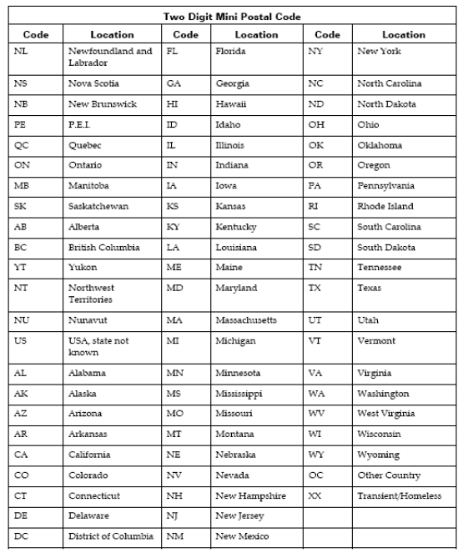

# Appendix-20: Morphology Codes

This is a complete listing of valid Morphology codes and includes the new Haematopoietic codes effective January 2010.

Citation for new classification:

WHO Classification of Tumours of Haematopoietic and Lymphoid Tissues, 4th ed., edited by S. H. Swerdlow, et al., International Agency for Research on Cancer, Lyon, 2008. ISBN 978-92-832-2431-0

(For details, please refer Cancer Care Ontario's Data Book - 2012-2013, Appendix 1.36 - Morphology Codes, at link https://www.cancercare.on.ca/ext/databook/db1213/databook.htm)

# Appendix-21: ICDO-3 Topography with Laterality

This is a table of topography codes where laterality is applied as stipulated in the FORDS manual.

(For details, please refer Cancer Care Ontario's Data Book - 2012-2013, Appendix 1.3 ICDO-3 TOPOGRAPHY with Laterality, at link https://www.cancercare.on.ca/ext/databook/db1213/databook.htm)